Preparing for Specialty
Interviews and Selection Centres
Tips for Interviewees
Use these reminders of the STAR CAMP, and SPIES question frameworks. They will help you deliver full and well-structured answers 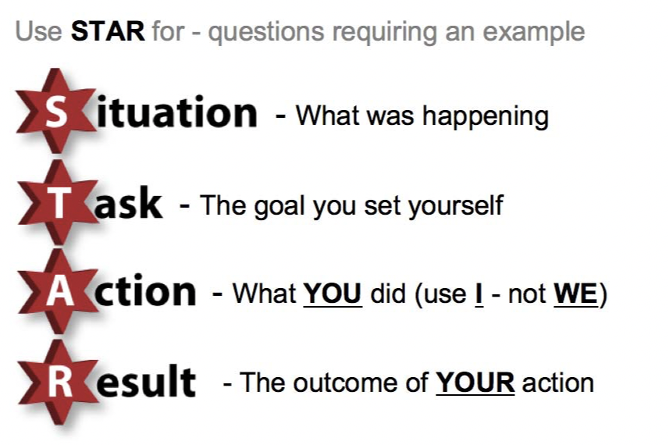
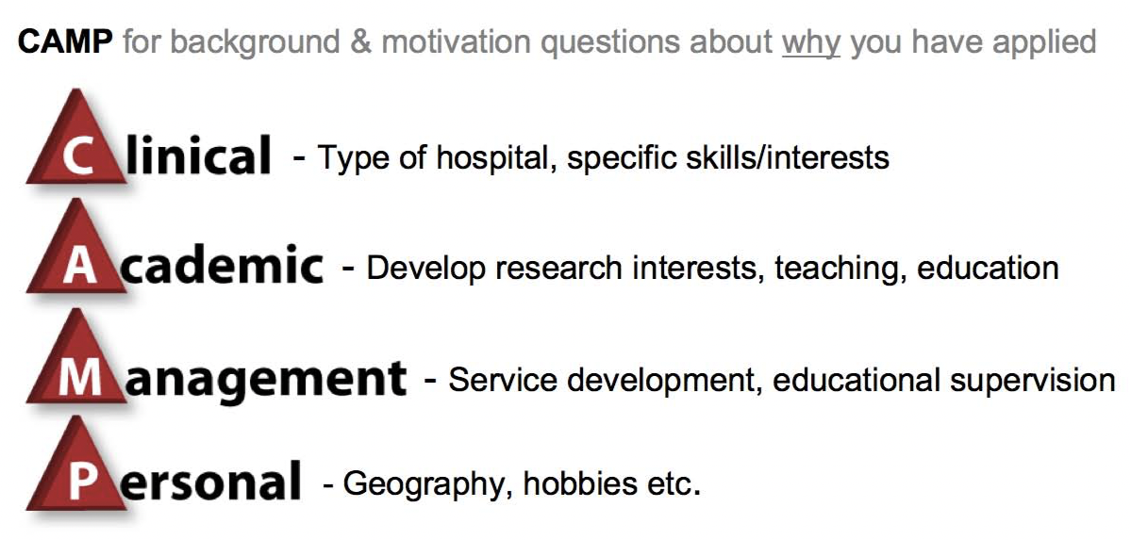
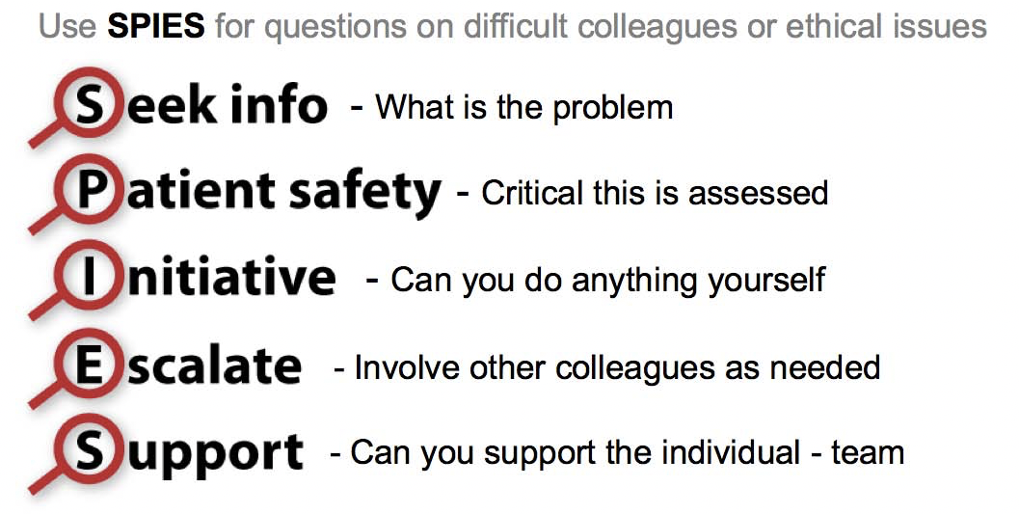

Questions – General interview questions
N.B If you have carried out an honest self-assessment and explored your career plans thoroughly you should find that interview questions will be easier to answer. Practice using the STAR -CAMP - SPIES frameworks.
Interviewers select 2 questions from the list below. Interviewee will have 5 minutes to answer each question before receiving feedback. Observer to monitor time and give a 1 minute warning before the 5 minutes is up and 2nd question is posed.
Section 1: General Interview Questions:
(About you: self-assessment: the sort of person you are, skills, knowledge, attitudes, values, motivation levels? Do you have the ability to get on with others, work in a team?)
Q1. What are the qualities of a good doctor? Do you have those qualities?
Q2. What will be the biggest challenge in this post for you?
Q3. Give me an example of where you managed a clinical scenario well? And one where things didn’t go so well?
Q4. You are dealing with an emergency on the ward and you are then called to review another patient urgently on a different ward. How do you prioritise and handle the situation?
Q5. How would you describe yourself?
Q6. Describe an occasion when you have worked well in a team?
Q7. What motivates you to give your greatest effort?
Q8. What skills or personal attributes do you possess that will make you a good trainee in this specialty?
Q9. How do you organise your workload?
Q10. Give an example of a situation where you showed leadership.
Q11. What skills do you need to improve?
Q12. What makes you a good team player? Give an example of a recent situation where you played an important role in a team. Give an example of a situation where you failed to act as a good team player?
(What distinguishes you from others: e.g. audits/research, teaching, courses attended & leadership skills etc.)
Q13. Describe your experience of the audit process? What did you gain from your research/audit experience? How do you critically appraise a paper?
Q14. Give me an example of where you showed leadership skills?
Q15. Tell us about any teaching experiences or presentations you have done. Discuss any new teaching methods that you are aware of?
(Ethical questions/knowledge about NHS systems:)
Q16. Your F1 colleague turns up drunk on the ward one morning, what do you do?
Q17. Tell me about clinical governance? Has clinical governance improved patient safety?

Questions specific to each specialty

Specialties included (click hyperlink to go directly to the questions)

Anaesthetics (includes ACCS Emergency Medicine)

Core Surgery

Internal medicine Training

Obstetrics and Gynaecology

Ophthalmology

Paediatrics

Public Health

Psychiatry

Radiology

Anaesthetics/ACCS

Q1. You are asked to review a patient (actor) on the ward. There will be an observations and drug chart. The patient is unresponsive and snoring heavily. Talk through your actions and present the case to an anaesthetist who arrives.

Interviewer to note/probe:
• Systemic approach: Airway, Breathing, Circulation, Disability (GCS), Examination, Glucose
• Formulate a logical plan. Maintain airway (chin life or Guedel), gives oxygen, call for help early, establish IV access, considers naloxone, investigations e.g. CT brain
• Scrutinise observations and drug chart, e.g. low respiratory rate, opiates, benzodiazepines.
• Presents case clearly and effectively to anaesthetist

Q2. A 55-year old man has been admitted with a severe, “sharp” epigastric pain present for several hours. His blood pressure is 88/45 mmHg and he is tachycardic. He appears pale and cool to the touch. On examination, there is epigastric tenderness and voluntary guarding, but the rest of his abdomen is soft. What is your differential diagnosis and how would you manage him?

Interviewer to note/probe:
• Formulate a reasonable list of differentials. • Resuscitate patient, i.e. I.V fluids. • Investigations including blood results, glucose, ECG & chest X-ray • Consider CT imaging if stabilized.

Q3. You are shown a pre-operative ECG of a young man undergoing elective arthroscopy. Interpret the ECG (complete heart block) and talk through your actions.

Interviewer to note/probe:
• Correctly interprets the ECG.
• Recognise potential risk – peri-operative bradycardia, asystole.
• Consult cardiologist for advice and consideration of pacing. • Reconsider options e.g. postpones procedure, involves patient.

Core Surgical Training:

Q1. You are a CT1 on-call. A 35-year-old man involved
in a road traffic accident (RTA) is in your emergency Department. He has pain and bruising in the left upper quadrant. Your registrar is scrubbed up in theatre. Tell me what you would do next?

Interviewer to note/probe:
• Systematic approach as in ATLS• Resuscitation: large-bore intravenous access, cross-match, fluids • Recognises potentially life-threatening injury, i.e. ruptured spleen • Involves consultant or second on call
• Inform theatre, involve anaesthetist

Q2. A 57-year-old man involved in a RTA is brought to A&E. He has a significant degloving injury of his right hand with cold and pale digits and an unpalpable radial pulse. How would you manage this patient? How long is the critical ischemia period?

Interviewer to note/probe:
• Systematic approach as in ATLS
• Resuscitation: large-bore intravenous access, cross-match, fluids • Recognises potentially life-threatening injury, i.e. ruptured spleen • Involves consultant or second on call• Inform theatre, involves anaesthetist

Q3. A 55-year-old man has been admitted with a severe, “sharp” epigastric pain present for several hours. His blood pressure is 88/45 mmHg and he is tachycardic.
He appears pale and cool to the touch. On examination, there is epigastric tenderness and voluntary guarding but the rest of his abdomen is soft. What is your differential diagnosis and how would you manage him?

Interviewer to note/probe:
- Formulate a reasonable list of differentials • Resuscitate patient, i.e. I.V fluids • Investigations including blood results, glucose, ECG & chest X-ray • Consider CT imaging if stabilized.

Internal Medicine Training

Q1. A 55-year-old alcoholic with known oesophageal varices presents with frank haematemesis and melaena. He is tachycardic but normotensive. Haemoglobin is 8g/dL (previously 12 g/dL). How would you manage this patient?

Interviewer to note/probe:
• Resuscitate, i.e. large-bore IV access, fluids, cross-match blood • Be aware of Rockall score
• Urgent endoscopy
• Consider antibiotics, glypressin, Sengstaken-Blakemore tube
• Inform seniors, consider critical care
• Consider prophylactic propranolol, TIPSS (transjugular intrahepatic portosystemic shunt)
• Alcohol cessation & rehabilitation (later, when recovering)

Q2. A 70-year-old smoker with COPD (chronic obstructive pulmonary disease) has just been admitted with severe breathlessness, wheeze, and cough with green sputum. He is talking in incomplete sentences through his oxygen mask with a respiratory rate of 18 breaths/min. On auscultation, he has reduced air entry and marked expiratory wheeze throughout. His arterial blood gas results are:
FiO2 : 0.75, pH: 7.35, pCO2 : 6.8kPA, pO2 : 21.1 kPA, Base excess : 4.9 mmol/L

What do these blood results suggest? How would you manage him?

Interviewer to note/probe:
• Identify compensated respiratory acidosis
• Recommend controlled oxygen
• Nebulizers, antibiotics, steroids, if appropriate; theophylline • Consider NIV (non-invasive ventilation) or ITU early on
• Later, smoking cessation, consider home oxygen

Q3. A 55-year-old man has been admitted with a severe, “sharp” epigastric pain present for several hours. His blood pressure is 88/45 mmHg and he is tachycardic.
He appears pale and cool to the touch. On examination, there is epigastric tenderness and voluntary guarding but the rest of his abdomen is soft. What is your differential diagnosis and how would you manage him?

Interviewer to note/probe:
• Formulate a reasonable list of differentials
• Resuscitate patient, i.e. I.V fluids
• Investigations including blood results, glucose, ECG & chest X-ray
• Consider CT imaging if stabilized

Obstetrics & Gynaecology:

Q1. As an F1, you’re called to see a patient 1 day post- hysterectomy. She is hypertensive and tachycardic. On examination you find her abdomen rigid with guarding and rebound tenderness. Your registrar is “scrubbed up” in theatre with an emergency Caesarean section and cannot respond. What do you do next?

Interviewer to note/probe:
• ABC, resuscitate, analgesia • Investigate: repeat bloods, arterial blood gas, erect chest X-ray (urgent)
• Escalate to consultant or second on call • Prepare for theatre: group and save, alert theatre, involve anaesthetist

Q2. As an F1, you have to call the locum consultant on call. He asks you to consent a patient for an exploratory laparotomy. Whilst on the phone, the patients husband arrives. He is very angry. What do you tell the consultant? How do you deal with the patient’s husband?

Interviewer to note/probe:
• As an F1 you don’t have the experience to consent for a laparotomy be firm with consultant • Know your limitations • Allow husband to express his feelings. Listen and explore concerns • Apologise and be sympathetic

Q3. Rank these 5 scenarios in order of priority. Explain what you would do and the reasoning behind your decisions:
• 45-year-old with previous endometriosis presenting with umbilical pain radiating to the right iliac fossa
• 50-year-old. 1 day post-hysterectomy hypertensive and tachycardic
• Elderly patient with calf pain, recently diagnosed with advanced ovarian cancer
• Pregnant woman, 30 weeks, with clots and large, fresh vaginal bleeding
• Referral from the medical registrar regarding a 65 year-old woman with post-menopausal bleeding

Interviewer to note/probe:
• Important to explain your rationale for your order of priority

Ophthalmology:

Q1. How would you approach discussing the result of a Chlamydia – positive swab to a patient with chronic conjunctivitis? Discuss treatment.

Q2. A 16-year old girl is referred to the eye casualty clinic with headaches and papilledema. What would you do?

Q3. You are in casualty clinic, a patient presents with sudden loss of vision in one eye. He is very worried. What would you do?

Problem Solving Scenarios:
Q4. You note that a colleague has prescribed the wrong treatment to a patient. How would you handle the situation?

Q5. What would you do if you had concerns that a colleague is putting patients at risk?

Q6. Your consultant is off sick. The clinic is very busy and running late. A patient is angry that he has been waiting a long time to be seen. You’ve seen him, but you are not sure what his diagnosis is. What do you do next?

Paediatrics:

Q1. What did you do during medical school / foundation to find out about a career in Paediatrics?

Interviewer to note/probe:
• Work experience e.g. summer school • Foundation jobs / tasters
• Societies / audits

Q2. A 16-year old boy presents with fever and photophobia and is suspected to have viral meningitis. He requires a lumbar puncture to confirm or exclude it. Your task is to explain the procedure to him and the reasons for doing it. The teenager thinks he only has the flu and is terrified of needles. (This scenario could be a role play at interview)

Interviewer to note/probe:
• This is about communication
• Adapt communication style to that appropriate to a teenager
• Importance of listening
• Explain the importance of excluding or diagnosing meningitis

Q3. How would you manage a 5-year-old child with a fever in the Emergency Department?

Interviewer to note/probe:
• Communication style required • Focused history and examination • Investigation and treatment

Psychiatry:

Q1. You are the ST1 on-call. There are 2 patients waiting to be seen:
• A 25 year-old woman with a deliberate overdose of seven paracetamol tablets she took 2 hours ago
• An agitated, delirious 80-year-old man on a medical ward who is trying to leave.

1. Who will you see first and why?
2. The elderly man is delirious and hallucinating. Tell me how you will assess and manage him?
3. How would you assess the 25-year-old woman? How would you evaluate her suicide risk?

Interviewer to note/probe:
This deliberately ambiguous with minimal information. There may be no right answer, you need to prioritise appropriately. The 80 year-old man will be at risk if he leaves the ward. Unless security are present he may “escape” soon. Consumption of seven paracetamol tablets is usually not fatal. Also, you need to wait 4 hours before you can request a blood test for levels.

Q2. What would you do if you suspected your consultant was becoming psychiatrically unwell?

Interviewer to note/probe:
• Ensure patient safety
• Ensure consultant safety
• Involve another consultant or clinical director
• Contact Occupational Health or the “Practitioner Health Programme”

Q3. What would you do if asked to assess a patient in the emergency Department who was refusing to speak at all?

Interviewer to note/probe:
• Involve someone the patient trusts to try and explain and encourage communication
• Observation to assess mood and signs of psychosis
• Collateral history from relatives, police, paramedics
• Physical examination (e.g. catatonic signs) and blood tests
• Consider personal safety – alarm buttons, joint assessment, positioning near exit

Public Health

Q1. What experience in your work, related to public health, has motivated you to pursue a career in public health?

Q2. Recent figures from emergency Departments across the country demonstrate a recent surge in the number of cyclists injured in road traffic accidents. How would you investigate this and what action would you suggest?

Interviewer to note/probe:
• Consult all stakeholders? (Emergency Depts, cyclists, local councils, schools , cycling groups)
• Attempt to identify causes for the upsurge (more cyclists, increased traffic density)
• Corroborate data with other sources
• Suggest a plan (speed cameras, educate cyclists) • Re-evaluate changes

Previous applicants have been asked to critically appraise a paper. They have also been asked if they would adopt a new initiative on the basis of the paper. This is an exercise in evidence-based medicine (EBM). Make sure you know about EBM, which is at the heart of public health.

Radiology:

Q1. You are informed by a radiology nurse that a colleague of yours is about to start doing an ultrasound-guided drainage procedure but she suspects your colleague is under the influence of alcohol. What would you do?

Interviewer to note/probe:
• Ensure patient safety: postpone procedure or find alternative operator
• Ensure colleague safety: find private place to rest, ask nurse to monitor
• Escalate: inform clinical director, another consultant
• Personal: offer support, talk to colleague

Q2. Tell us about a case you have been involved in where radiology was central to your patient’s management?

Q3. Increasingly, non-radiologists are involved in image interpretation or interventional work. For example, specialist radiographers now interpret images. Will there still be a need for radiologists in the future?

